
FACULTY OF TECHNOLOGY AND ENGINEERING
DEVANG PATEL INSTITUTE OF ADVANCE TECHNOLOGY
AND RESEARCH

DEPARTMENT OF COMPUTER ENGINEERING

A.Y 2026 – 27 Semester – 3

LAB MANUAL

CSUC201 Fundamentals of Data Structures and Algorithms

Practical 6: Stack Implementation using Array and Linked List, with Expression Processing

Practical Aim:
To implement stack using array and linked list, and apply stack-based logic to expression conversion, evaluation, and bracket validation problems.

Problem 1 :
A cafeteria stacks clean trays on a fixed-size counter. New trays are always placed on top, and customers always take from the top. The counter can hold at most n trays at a time — if it is full, no more trays can be added, and if it is empty, no tray can be taken. Given a sequence of place and take operations, implement this fixed-capacity tray stack and print the current top tray after each operation. Report an error if a place or take operation cannot be performed.
Describe how your solution tracks whether the stack is full or empty. What are the exact conditions you check before a push and before a pop, and what does your program do when those conditions fail?

Link:
https://github.com/yakshu205/DSA/tree/main/Sorting%20algo/practical-6
Output:
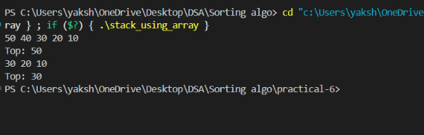

Conclusion:
The program implements a fixed-capacity stack using an array and a top pointer. It checks for overflow before push and underflow before pop, displaying an error when the operation cannot be performed.

Problem 2 :
A web browser keeps track of pages visited so that the back button always returns to the most recently visited page. Unlike a fixed counter, the browser has no hard limit on how many pages it can remember — it grows as the user visits more pages and shrinks as they press back. Given a sequence of visit and back operations, implement this unlimited page history and print the current page after each operation.
Describe how your solution differs from Problem 1 in how it handles memory. What happens in your solution when the user presses back on the very first page with no history left?

Link:
https://github.com/yakshu205/DSA/tree/main/Sorting%20algo/practical-6

Output:
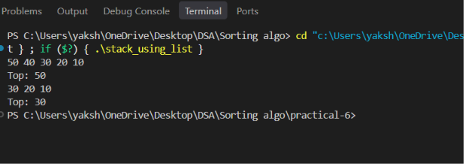

Conclusion:
The program implements an unlimited stack using a linked list, allowing pages to be added dynamically without a fixed capacity. If back is pressed when no history is left, it displays an error message and performs no operation.

Problem 3 :
A calculator application receives arithmetic expressions typed by users in the usual way — numbers and operators written in between, with brackets to control priority (e.g. 3 + 4 * 2 or (3 + 4) * 2). Internally the calculator needs to convert each expression into a form where operators appear after their operands, so it can evaluate them without needing to re-read brackets. Given an infix expression, convert it to the equivalent postfix form and print the result.
Describe the role the stack plays in your conversion. What does your solution do when it encounters a closing bracket, and what happens to the operators that were waiting on the stack at that point?

Link:
https://github.com/yakshu205/DSA/tree/main/Sorting%20algo/practical-6

Output:
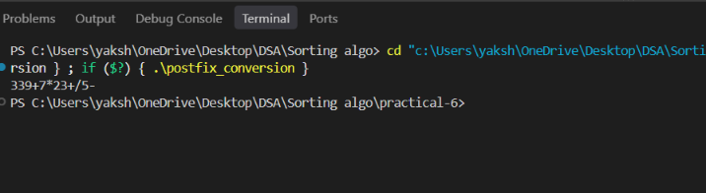
Conclusion:
The program uses a stack to temporarily store operators and maintain their precedence. When a closing bracket is found, operators are popped from the stack until the matching opening bracket is found, and the popped operators are added to the postfix expression.

Key Questions / Analysis / Interpretation to be Evaluated During/After Implementation:

[Problem 1] A circular array is one way to reuse freed slots without shifting all elements. Without implementing it, explain what change would need to be made to your front and rear pointer logic to make the array behave circularly, and what new condition would indicate a full array.
Sol: Front and rear should wrap around to the beginning of the array using modulo when they reach the end.
The queue is full when the next rear position becomes the front position.

[Problem 2] Your linked list stack has no fixed capacity limit. But in practice, can it still run out of space? What determines the actual limit, and why is that limit invisible in your code?
Sol: Yes, it can run out of space. The actual limit depends on the available RAM and system memory.
This limit is invisible in the code because nodes are created dynamically without checking the total available memory.

[Problem 3] operator precedence determines the order in which operators are placed into the output. Without tracing any expression, explain what would go wrong in your output if your solution treated all operators as having equal precedence.
Sol: If all operators had equal precedence, the postfix expression could place operators in the wrong order.
For example, multiplication should be performed before addition, but treating them equally could produce an incorrect result.

